Fast Food Marketing Analysis

# Fast Food Marketing Scenario

A fast-food chain plans to introduce a **new menu item** and is considering **three marketing campaigns** to promote it. The goal is to identify **which campaign yields the highest sales**.

**Test**  
The new item will be **launched** in several **randomly selected markets**, **each** using a **different promotion**.   
Weekly sales will be recorded for the first four weeks.

**Measurement**  
Sales data includes:

* **MarketID**: Unique identifier for the market
* **MarketSize**: Size of the market by sales
* **LocationID**: Store location identifier
* **AgeOfStore**: How old the store is (in years)
* **Promotion**: The type of promotion (one of three)
* **Week**: Which week of the promotion (1 to 4)
* **SalesInThousands**: Sales for each Location, Promotion, and Week

# Approach

**Data Aggregation**

The focus is on total sales by location and promotion.

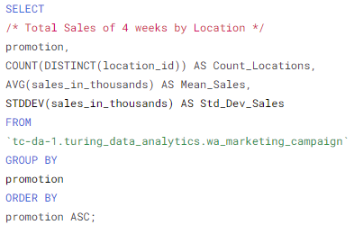

**Pairwise Comparisons (A/B Testing)**

Three comparisons will be made:

* Promotion 1 vs. Promotion 2
* Promotion 2 vs. Promotion 3
* Promotion 1 vs. Promotion 3

# Sanity Checks: Ensuring Group Comparability

Before evaluating the experiment results, it is essential to confirm that the three promotional groups   
are indeed comparable.  
This step ensures that any differences in the results are due to the effect of the promotions   
and not because of a discrepancy in the population sizes or other characteristics.

## Sanity Check 1: Population Size per Group

**Conclusion**  
The **population sizes are statistically comparable**,   
suggesting that the groups can be **treated as equal for further analysis** in the promotion tests.

## Results

**See → Excel Tab: Aggregation for T Test**

The population sizes of the three groups are 43, 47, and 47, respectively.   
After calculating the mean population size, standard deviation, and margin of error   
at a 95% confidence interval, the resulting confidence interval shows   
that the differences in population sizes fall within the margin of error.

  
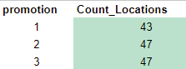

## Sanity Check 2: Distribution of Total Sales by Market Size

**Summary**The analysis confirms that the promotional groups are **comparable**, especially in **medium markets**,   
allowing for valid assessments of promotional effectiveness.   
However, the **deviations of large market location** count from the average for Promotions 2 and 3   
could **impact comparability**, as the large market significantly influences overall sales performance.   
The **Small market’s** **limited** **data** should be considered in future analyses.

## Results

**See → Excel Tab: Sanity Checks**

The distribution of total sales across market sizes indicates the following:

**Location Count:**The Large (12-16 locations) and Medium (24-29 locations) markets have sufficient data for analysis, while the small market has fewer locations (4-6), which **may limit the robustness of conclusions**.  
  
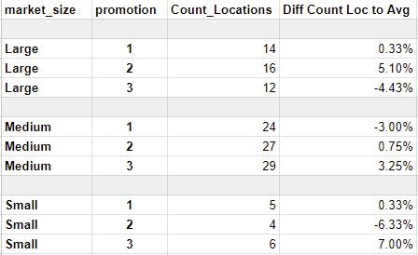

**Sales Performance:**

* **Large Market**: Total sales range from $3.7 million to $4.2 million,   
  with mean sales per location between $241.29 and $308.82, indicating **strong performance**.
* **Medium Market**: Total sales range from $4.2 million to $5.3 million,   
  with mean sales per location between $156.46 and $190.69, showing **decent performance**.
* **Small Market**: Total sales are lower, ranging from $813,000 to $1.4 million, reflecting **limited impact**.
* 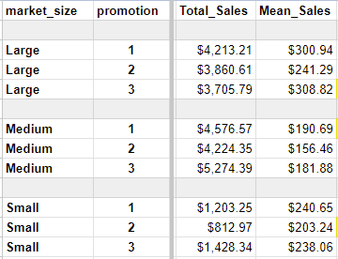

**Variability:**

* The **Large Market** has a moderate Coefficient of Variation (CV) of 18.3% to 25.8%,   
  indicating **the highest variability in sales performance.**  
    
  The Medium Market shows lower variability (CV of 13.9% for Promotion 1),   
  indicating **stable sales performance.**
* The Small Market has the lowest variability (CV of 3.8% to 7.2%),   
  pointing to **consistent sales** among few locations.

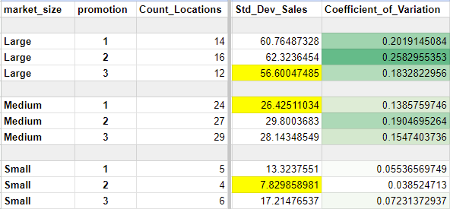

# Statistical Testing

## Hypothesis

For each of the 3 comparisons a **Statistical Test (T-Test)** will be usedto determine   
if there is a statistically significant difference in sales between promotions:

* Null Hypothesis (H0): There is no difference in sales between the two promotions.
* Alternative Hypothesis (H1): There is a difference in sales between the two promotions.

## Statistical Significance

To mitigate the risk of Type I error due to multiple comparisons:

The original significance level is set at **99% (α = 0.01)**.

**Bonferroni Correction**:



## Assumptions Check for the T-Test

* 1. **Independence**  
     Sales data from different locations are independent.



[This Photo](https://en.wikipedia.org/wiki/File:Checkmark_green.svg) by Unknown Author is licensed under [CC BY-SA](https://creativecommons.org/licenses/by-sa/3.0/)

* 1. **Normality**   
     T tests are robust to non-normal data with large sample sizes (n>30)   
     due to the **Central Limit Theorem**.



[This Photo](https://en.wikipedia.org/wiki/File:Checkmark_green.svg) by Unknown Author is licensed under [CC BY-SA](https://creativecommons.org/licenses/by-sa/3.0/)

Visual check for data distribution for better understanding:

**See → Looker Studio Report**

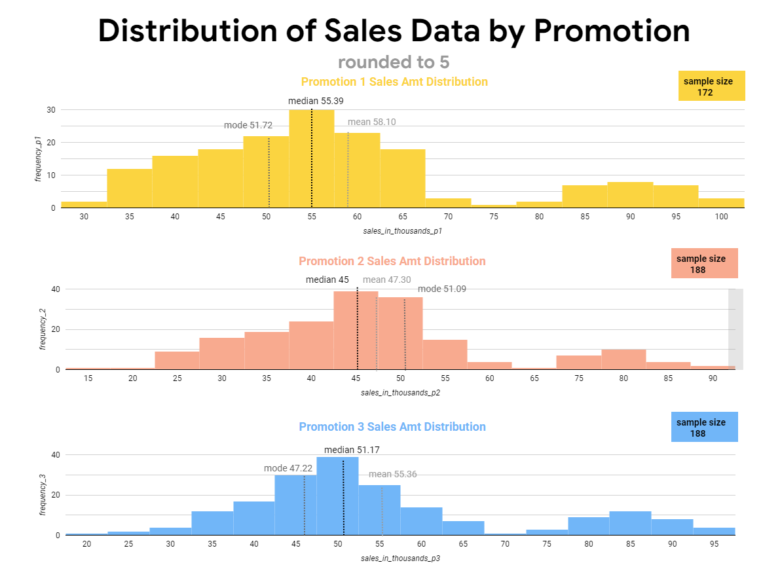

* 1. **Equal Variances:**   
     The variance ratio in all comparisons is <2,   
     this makes it safe to assume equal variances for all tests:

**See → Excel Tab: Aggregation for T Test**



## T-Test

**Conclusion**

The T-Tests suggests that Promotion 1 is the most effective, while Promotions 2 and 3 perform similarly.  
The T-test results indicate that **Promotion 1** significantly **outperforms Promotion 2** in average sales with 99% confidence. However, there **is no significant difference in average sales between Promotion 2 and Promotion 3**, nor between **Promotion 1 and Promotion 3**.

## Result T-Tests

**See → Excel Tab: T-Tests**

Promotion 1 vs promotion 2: **Promotion 1** has a significant **higher** average sale   
with 99% confidence value compared to Promotion 2.

Promotion 2 vs promotion 3:There is **no significant difference** in average sales.

Promotion 3 vs promotion 1:There is **no significant difference** in average sales.

## Detail Promotion 1 vs Promotion 2

* **Null Hypothesis (H0): There is no difference in sales between the two promotions.**

**Rejected**

* **Alternative Hypothesis (H1): There is a difference in sales between the two promotions.**

**True, Promotion 1 Mean is greater.**

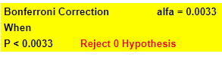

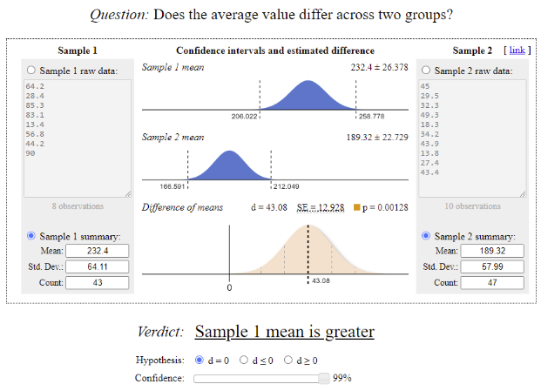

## Detail Promotion 2 vs Promotion 3

* **Null Hypothesis (H0): There is no difference in sales between the two promotions.**

**True**

* **Alternative Hypothesis (H1): There is a difference in sales between the two promotions.**

**Rejected**

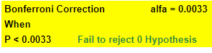

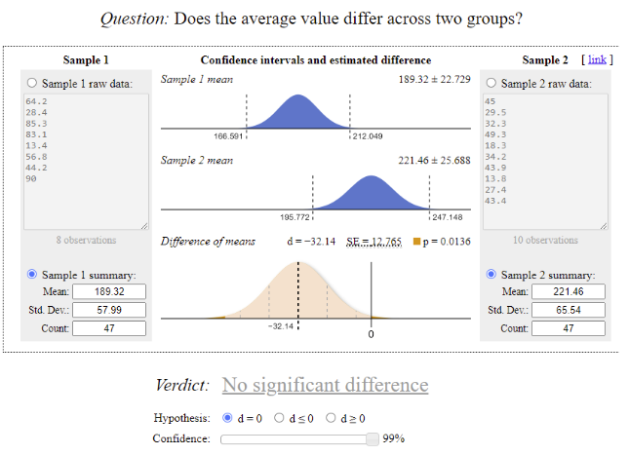

## Detail Promotion 3 vs Promotion 1

* **Null Hypothesis (H0): There is no difference in sales between the two promotions.**

**True**

* **Alternative Hypothesis (H1): There is a difference in sales between the two promotions.**

**Rejected**



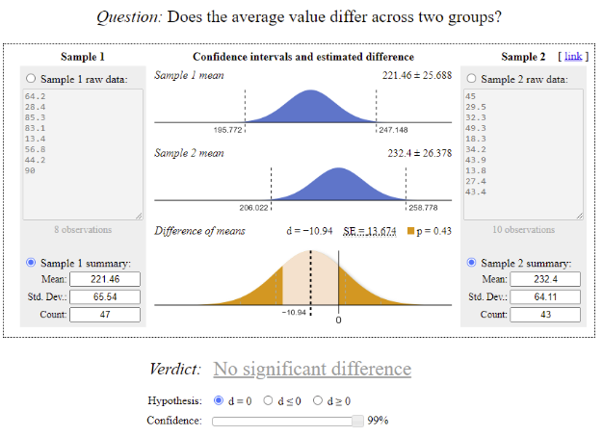

# Conclusion

Based on the analysis and T-tests, Promotion 1 is the most effective, significantly outperforming Promotion 2 with 99% confidence. There is no significant difference between Promotion 1 and Promotion 3 or between Promotion 2 and Promotion 3, indicating that Promotions 1 and 3 are similarly effective. Promotion 2, however, consistently shows the weakest performance.

# Implications from Sanity Check 2:

Regarding the conditions identified in Sanity Check 2, we cannot make strong conclusions about the comparability of the promotional groups, particularly in the Large market. The deviations in location counts for Promotions 2 and 3 may have influenced results, as the Large market significantly impacts total sales.   
Additionally, the Small market's limited data introduces uncertainty and may affect conclusions drawn for smaller market segments.

# Final Recommendations:

1. **Promotion Selection**:
   * **Choose Promotion 1 or 3**: Both Promotion 1 and Promotion 3 performed similarly, with no significant difference in average sales. Given this, either promotion can be a viable choice.   
     However, **Promotion 1** showed significantly **higher sales** compared to Promotion 2, making it a **slightly stronger candidate overall**.
2. **Further Testing**:
   * **Additional Testing for Promotion 3 in Large Markets**: Promotion 3 had fewer locations in the Large market, which may have affected the accuracy of results. Additional testing in this market could provide more reliable insights and strengthen the case for Promotion 3.
   * **Expand Data in Small Markets**: Increasing the number of locations in Small markets for both Promotion 1 and Promotion 3 will enhance the robustness of conclusions and offer a more confident assessment of promotion performance across all market sizes.
3. **Discontinue Promotion 2**: Promotion 2 consistently underperformed compared to the other two, showing significantly lower sales. It should be discontinued.
4. **Consider Strategic Fit**: Since there is no significant difference between Promotion 1 and Promotion 3, other factors such as costs, demographics, or market preferences should be considered when making the final decision.